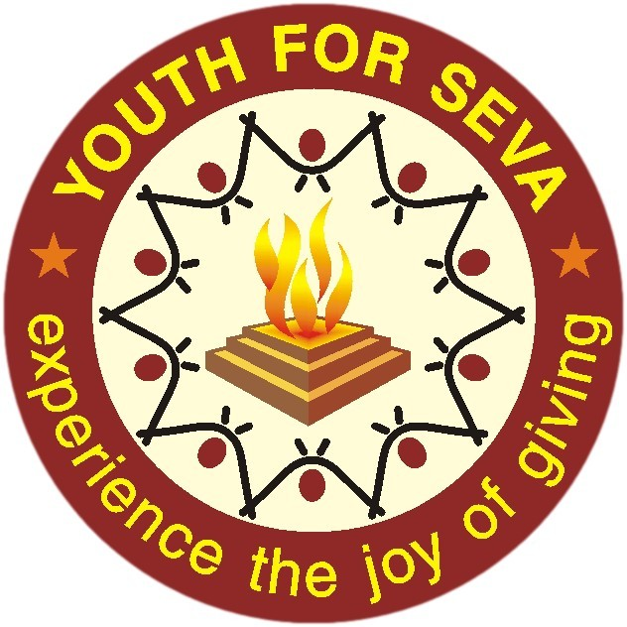

Co-ordinator – Vidya Chetana & College Relations @ YFS, Chennai

Job Description
We are looking for a young and passionate person fresher (One who engaged in social activities in their college days) or who has at least 1 year work experience, preferably in the social sector to coordinate in the engagement of college volunteers in meaningful social activity. He/she will work with the students, College Management and also on Vidya Chetana Project.

The task include:

- Vidya Chetana:

- Vidya Chetana Scholarship Program, which aims to provide scholarship support to students with serious financial constraints to pursue College / Higher education.
- Promoting Vidya Chetana Program to needy children & communities, Help students get registered, Admission guidance for College and Course selections, Coordinate for Values & Volunteering workshops, Career Guidance sessions & Workshops on Soft Skills, 21st Century Skills workshops, Support Employment readiness program for final year students.
- Engage with students to mould them into socially conscious citizens & inculcate volunteering as a way of life.

- College Relations work:

- Promote the spirit of Social Responsibility amongst the local and regional students
- Proactively engage College Students, understand their volunteering needs; propose suitable opportunities.
- Execute College relations annual plan
- Organize and host YFS orientation to college students
- Mobilizing college volunteers for YFS internal volunteering activities
- Reporting and Documentation on weekly, monthly, quarterly and annual basis.

Selection Criteria
- PREFERENCE WILL BE GIVEN TO LOCAL CANDIDATES

Location | Chennai, Tamilnadu
Age | 21yrs to 35yrs
Education | Post Graduate Degree in Social Work (MSW) with Community Organization/Development practice is preferred, Or  Passionate graduate- Degree Holder from a recognized University.
Languages needed | English, Tamil and any other languages
Commitment | 1 year to 3 years
Work Timing | 9.30am – 6pm –  Able to work flexible hours, including evenings and weekends.
Skills | - Excellent communication skills (Written and Oral) in English and conversational skill in Telugu is a prerequisite.  - Good documentation and computer skills are essential. Basics of MS Word, Excel, PowerPoint and Use of internet, e-mail, etc.
Other requirements | - The person should be ready to travel as the work requires 50% field work.  - Passionate about Social Sector

If you are interested, please send your resume to hryfs@youthforseva.org with subject line “Co-ordinator –Vidya Chetana and College Relations @ Chennai”

